Part 2: Design and Threat Modeling
Project Title: Secure Library Management System
Submission Date: March 7, 2026

1. Data Flow Diagram (DFD) - Level 0
The following diagram illustrates the flow of data between the Librarian (Actor), the Library Management System (Process), and the Database (Data Store). It also identifies the Trust Boundary where data validation must occur.
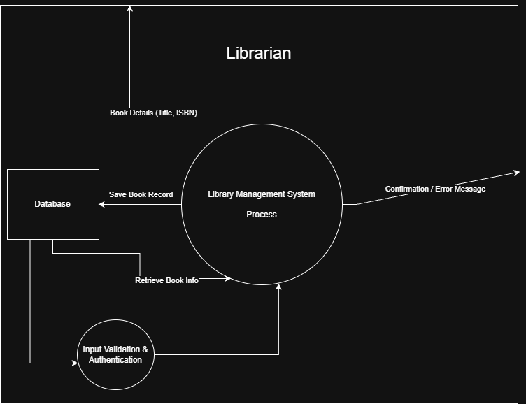

2. STRIDE Threat Analysis
In this section, we apply the STRIDE methodology to identify potential security threats based on the DFD transitions. Each threat is linked to a specific component of the system.
Element | Threat Type | Threat Description | Mitigation Strategy
Login Flow | Spoofing | An attacker may attempt to impersonate a Librarian using brute-force or stolen credentials. | Implement Account Lockout Policy and Password Hashing (BCrypt).
Book Input | Tampering | A malicious user may inject SQL commands into input fields (e.g., Book Title) to alter database records. | Use Parameterized Queries (Prepared Statements) and strict Input Validation.
Transaction Logs | Repudiation | A user might deny performing a specific action (e.g., deleting a book) if the system lacks logging. | Implement a Secure Audit Logging system to track all "Write" operations.
Database Store | Information Disclosure | Unauthorized access to the database could lead to the leakage of sensitive member information. | Apply Data Encryption at Rest and restrict database file permissions.
System Process | Denial of Service | An attacker could flood the system with massive search queries to crash the application. | Implement Rate Limiting and optimize database indexing.
User Roles | Elevation of Privilege | A standard user might attempt to access administrative functions like "System Configuration." | Enforce Role-Based Access Control (RBAC) at the application level.

3. DREAD Risk Assessment
We have prioritized the identified threats using the DREAD scoring system (Scale 1-10) to determine the risk level.
Threat | Damage | Repro | Exploit | Affected | Discover | Total Avg Score
SQL Injection | 10 | 8 | 7 | 9 | 8 | 8.4 (Critical)
Credential Theft | 9 | 7 | 6 | 10 | 7 | 7.8 (High)
Data Leakage | 8 | 5 | 5 | 10 | 6 | 6.8 (Medium)

